

College of Engineering

Department of Electrical and Computer Engineering

**System Description Report**

**Low Voltage Power Supply**

**Team Motorvators (Team 20)**

**Cyrus Yousefian, Pamela Gallardo, Tyler Chu, Joseph Fraticelli, and Bader Alshammari**

Meet the team

**Table of Contents**

|  |  |
| --- | --- |
| **Criteria** | **Page(s)** |
| Executive Summary: | 4 |
| Functionality: | 5 |
| Inputs & Outputs: | 5 & 6 |
| Use Case: | 6 |
| Physical Description & UI: | 7 – 9 |
| Development vs Procurement: | 10 – 12 |
| Specifications: | 1. – 14 |
| Validation by Test: | 15 -17 |

# Executive Summary:

The General Low Voltage Power Supply (GLV) for the Aztec Electric Racing (AER) vehicle is a Printed Circuit Board (PCB) enclosed in a modular, compact, fireproof, waterproof, and easy to assemble/disassemble enclosure. The purpose of the GLV is to supply power to all onboard low voltage electronics on the AER vehicle via the use of an onboard low voltage battery pack. To achieve this, the PCB will be divided into five main circuits: battery management system (BMS), DC input for recharging the cells of the battery pack, dual voltage DC output, user interface (UI), and information logging. The BMS mainly consists of a microcontroller in the form of an ESP32 from the Wrover family of products and a BMS IC from the TI-BQ769x0 family which will handle cell balancing and battery protection features. The DC input will be handled by an AC-DC wall power adapter which brings power to the PBC via a barrel jack. The dual voltage DC output will be handled by DC-DC converter that will create two voltage rails, 12V and 24V, the rails will be able to deliver up to 5A and 10A respectively. The UI will consist of a display and momentary switch on the front of the GLV. The display will give the user information regarding battery performance and system power draw. The user will be able to request the logging of system information via the momentary switch located on the front of the GLV. The logs will be written to an onboard SD card as a .csv file for the user to be able to review later. The following sections of this document cover functionality, inputs & outputs, use case, physical description & UI, development versus procurement, specifications, and validation in detail. In the next section, we will be exploring the functionality of the GLV device.

# Functionality:

The Motorvator’s General Low Voltage Power Supply is a compact and rechargeable, dual-output power supply that will assist the AER team by powering the vehicle’s on-board, low-voltage electronics during competition. The internal BMS protects the power supply against short circuits, overcharging, over-discharging, and damage from high temperatures. The microcontroller interfaces with the BMS integrated circuit through the I2C protocol and data bus to extract and process power supply data, namely voltage, current, and temperature. This data will be sent to the built-in display to indicate when the power supply must be charged and to allow the AER team to determine the near real-time status of the device. As a backup, the microcontroller will also write this data to a log in the micro-SD card at the behest of the user.

# Inputs & Outputs:

As an external input, the AC-DC wall adapter provides direct current to the PCB from which the BMS IC supplies power to the battery cells. This allows for easy rechargeability from any standard North American 120V wall outlet. As an external output, the 18650 lithium-ion battery cells shown in figure 2 of the device outputs 24V at a max of 10A and 12V at a max of 5A to the AER race car’s low-voltage electronics. Internally, these cells also supply 3.3V to power the ESP32 microcontroller through the integrated voltage regulator of the TI-BQ769x0 series BMS IC outlined in figure 2. The BMS outputs digital data encompassing voltage and current levels as well as temperature via thermistor to the data bus from which the microcontroller reads and processes using the I2C protocol. The microcontroller then outputs this digital data to a micro-SD breakout board using the serial peripheral interface (SPI) protocol. This micro-SD card stores power supply information as a .csv file that can be extracted and read through an external computer. The microcontroller is also responsible for outputting the digital data to the LCD screen for display using the I2C protocol once again.

# Use Case:

The GLV for AER’s Formula Electric Race Car (FERC) is being developed to power all low voltage electronics on the vehicle (vehicle dashboard, PCM, etc). Prior to our project, there was an existing model, however, it was very inconvenient in many aspects for AER. For example, there were rechargeable batteries, however, in order to recharge them it required the team to physically remove the power supply from the car, desolder wires and finally hook it up to a bench-top power supply. This is not very practical, as a power adapter would be more efficient for rechargeability, allowing the racers to plug the power supply into the wall when charging is needed. With practicality in mind, the design should not have to be tampered with in order to perform essential functions such as charging. In past competitions, the power supply used buzzers to indicate it was “on” and functioning correctly, with no method of collecting how effective/efficient the batteries were working together. For testing purposes, the chassis will include a display providing information about the batteries, such as temperature, voltage, and current output. In addition to displaying information, there will be an micro-SD Card that will store the data in the form of a .csv file. By collecting data, the user is able to analyze the performance and state of the vehicle. This can be accomplished by comparing the data after each race to ensure compliance with discharging/charging protocols and sufficient temperature ranges.

# Physical Description & UI:

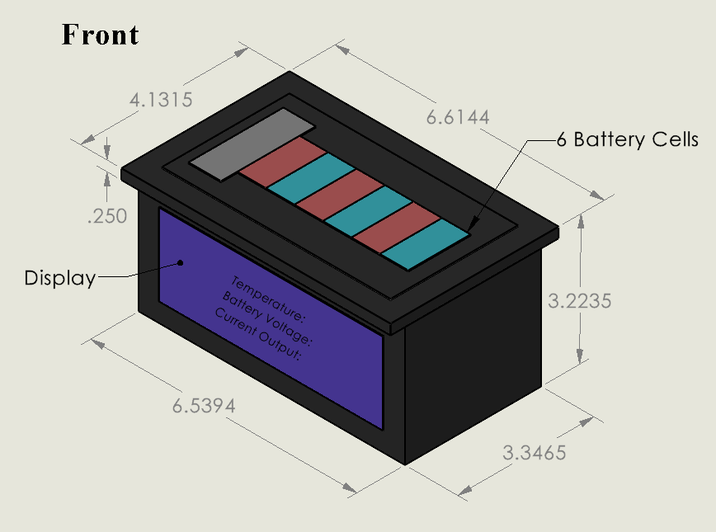

Figure 1 Front of device (measurements in inches) showing UI and location of battery cells

Figure 2 Back of device (measurement in inches) Showing interior where PCB is and parts of PCB and how the battery cells connect to the PCB

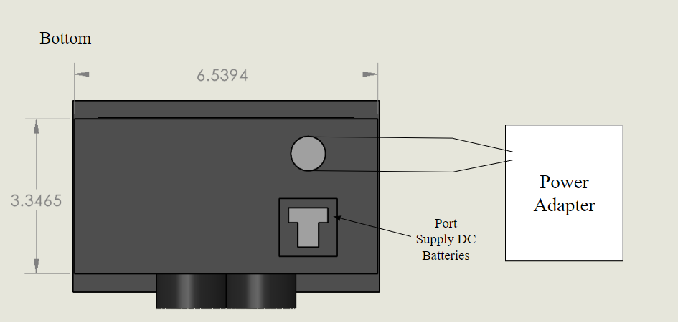

Figure 3 Bottom of device showing DC output and DC input

# Development vs Procurement:

The GLV is a PCB housed in a 3.4 inch by 6.7 inch container to follow FSAE Rule guidelines. The budget outlined by the project sponsor is $1,000. The BMS inside the container provides a dual output of 24 V at max 10 A and 12V at max 5A. This inturn powers the low voltage electronics the FERC. The components procured for the GLV include BMS IC, ESP 32-S2 Development Kit, Lithium-ion cells, power adapter (AC-DC wall adaptor), dual port to power the FERC, micro-SD card, SD Card module, and DC-to-DC Converters. We will also procure additional subcomponents needed to support the main components, including power MOSFETs, current sense resistors, resistors, thermistor, fuse holders, Liquid Crystal Display (LCD), jumper wires, momentary switch, schottky diodes, complementary capacitors, barrel jack, and Deutsch connector. We will develop our own embedded software to control and support components like the ESP 32 Development Kit (microcontroller), data bus, and potentially our own android app.

## BMS IC

The GLV has multiple requirements, including battery cell charging, battery cell discharging, and temperature readings of the battery cells. To be able to meet these requirements, we need to procure the TI-BQ769x0 series BMS IC. The TI-BQ769x0 series BMS IC comes with the I2C protocol, which enables us to communicate with it through the use of a microcontroller (MCU). Also, building our BMS through the assistance of essential components like a BMS IC allows us to become more familiar with Battery Management Systems.

## ESP 32-S2 WROVER Development Kit

The ESP 32-S2 WROVER Development Kit is a Wi-Fi MCU is a procured component. The Development Kit was selected because it is compatible with our BMS IC through the I2C protocol, the Development Kit comes with 4MB of Serial Peripheral Interface (SPI) Flash and 2MB **Pseudostatic DRAM** (PSRAM)**.** The development kit can be configured to provide functionalities needed for our development, including 13 – bit ADC and 8 – bit DAC. An additional benefit of this development kit is that we can supply our developed reflashable firmware to the AER team if they need to replace the MCU in the future.

## Lithium-Ion Cell Stacks

We will procure at least 6 18650 lithium-ion battery cells due to the dependency of cell count by the BMS IC procured. Also, the capacity of the batteries we need is to ensure that the GLV can be used during the entirety of an FSAE competition event.

## Data Bus

We will develop/implement one I2C data bus and one SPI data bus on our PCB to interconnect our (slave) devices, including the BMS IC, SD Card Breakout Board, and display to the MCU (master) host device.

## Dual Output Port

The battery pack inside the container powers the dual output port, which powers the FERC’s low voltage electronics at 24 V at max 10 A or 12V at max 5A.

## DC to DC Conversion

We will procure DC-to-DC Converters which convert the voltage from the battery pack into two different rails, 12V and 24V. The rails will be able to deliver up to 5A and 10A of direct current respectively. Therefore, we will procure DC-to-DC Converters because our GLV must have regulated dual output capabilities.

## Wall Power Adapter

We will procure a 120V AC-DC Power Adapter, which will be needed to power to the PCB.

## Micro-SD Card

We will procure a micro-SD card to store collected data such as voltage, current output, and temperature from the MCU using the SPI protocol. The micro-SD is inexpensive and needed to store data for our GLV project.

## SD Card Module

We will also procure an SD Card Module to facilitate the connection between our micro-SD card and MCU.

# Specifications:

The device must be capable of supplying 24V at 10A.

The device must be capable of supplying 12V at 5A.

The device shall be powered by rechargeable batteries.

The device must be capable of operating on a single charge during the entirety of a competition event.

The device must have a battery management system with the below protection features:

* Short circuit protection
* Over-charge protection
* Over-discharge protection
* High-temperature protection

The device shall be equipped with a display.

The display must provide the user with the following information:

* Battery temperature
* Battery voltage
* Current output

The device shall be equipped with an SD card reader.

The device must be capable of logging battery temperature, battery voltage, and current output to the micro-SD card as a .csv, at the behest of the user.

The batteries in the device shall be recharged via the use of an external AC wall power adapter.

The device must be housed in a modular, compact, fireproof, waterproof, and easy to assemble/disassemble enclosure, supplied by the ME team.

# Stretch Specification:

The device must be Bluetooth enabled.

The device shall be accompanied by an Android application.

The accompanying Android application must be capable of interfacing with the device via the use of Bluetooth technology.

The user must be able to log battery temperature, battery voltage, and current output via the use of the accompanying Android application.

Table 1: Device component breakdown for better visualization



# Validation by Test:

To validate that our device can supply 10A at 24V, we will connect the output of the 24V rail to a 10A load. We will have two digital multimeters (DMM), one in parallel to the load to measure the voltage across it and one in series to measure the current. If we get 24V and 10A on the respective DMMs then we have met the specification.

To validate that our device can supply 5A at 12V, we will connect the output of the 12V rail to a 5A load. We will have two DMMs, one in parallel to the load to measure the voltage across it and one in series to measure the current. If we get 12V and 5A on the respective DMMs then we have met the specification.

To validate that our device can operate on a single charge for the duration of one race. We will discharge the device for 33minutes (30 minutes the longest time for a race + 3 minutes as a 10% buffer), by applying a 5A load to the 12V rail and a 10A load to the 24V rail. After 33 minutes have elapsed, we will measure the voltage of the battery pack using a DMM in parallel. If the voltage of the two rails is still 12V and 24V, then this specification is validated.

To validate the short circuit protection feature, we will probe the gate and source of the discharge power field effect transistor (FET), using a DMM. We will short the pack+ and pack- connections together. If we see of the discharge FET drop below , the specification is validated.

To validate the over-charge protection feature, we will begin charging the batteries of the device, via the AC wall power adapter. We will monitor the voltage of each cell by having a DMM in parallel. Using a DMM, we will probe the gate and source of the charge power FET. Once the voltage of the cells reaches 4.2V, if of the charge FET is less than the , the specification is validated.

To validate the over-discharge protection feature, we will begin discharging the batteries of the device, by applying a load across pack+ and pack-. We will monitor the voltage of each cell by having a DMM in parallel. Using a DMM, we will probe the gate and source of the discharge power FET. Once the voltage of the cells reaches 3V, if of the discharge FET is less than the , the specification is validated.

To validate the high-temperature protection feature, we will begin discharging the batteries of the device, by applying a load across pack+ and pack-. Using a DMM, we will probe the gate and source of the discharge power FET. We will apply hot air to the thermistor attached to the battery pack. Once is achieved, if of the discharge FET drops below , the specification is validated.

To validate logging info to the onboard SD card, we will request the system to log the battery temperature, battery voltage, and current output, outputting that data to a .csv file. We will then apply various loads across the 24V rail and the 12V rail. We will then request the system to stop logging. We will remove the SD card from the device and read the contents of the .csv file using a PC. If the contents are not NULL and seem to be feasible values, the specification is validated.

To validate the data on the display, we will set up two DMMs one in parallel with pack+ to measure the voltage, and one in series with pack+ to measure the current output. To measure temperature, we will attach an external Type-K thermocouple to the battery pack. We will then compare these values to the data on the display of the device and if they are similar, the specification has been validated.

# Validation by Inspection:

We will look at the device to see that rechargeable batteries are powering it. If it is, then the spec is validated.

We will look at the device and ensure that its method of recharging the batteries is via the use of an external AC wall power adapter. If it is, then the spec is validated.